CLOUD COMPUTING: SOFTWARE SHARING OVER A PRIVATE CLOUD

A PROJECT REPORT

Submitted by

Zeeshan Akhtar
(0701010120)
Sachin Srivastava
(0701010080)
Saurabh Gupta
(0701010088)
Sudhanshu Gupta
(0701010101)

in partial fulfillment for the award of the degree

of

B.Tech

IN
Computer Science & Engineering

United College of Engineering and Research, Allahabad
GB Technical University, Lucknow

May, 2011

Certificate

This is to certify that this project report entitled “CLOUD COMPUTING: SOFTWARE AND STORAGE SHARING OVER A VIRTUAL NETWORK” by ZEESHAN AKHTAR (0701010120), SACHIN SRIVASTAVA (0701010080), SAURABH GUPTA (0701010101) and SUDHANSHU GUPTA (0701010088), submitted in partial fulfillment of the requirements for the degree of Bachelor of Technology in Computer Science and Engineering of the UP Technical University, Lucknow, during the academic year 2010-11, is a bonafide record of work carried out under my guidance and supervision.

AHMAD KHAN
Designation, Deptt. of Computer Science,
United College of Engineering and Research, Allahabad

Acknowledgements

We would like to express our sincere gratitude to our project guide Mr.AHMAD KHAN sir for giving us the opportunity to work on this topic. It would never be possible for us to take this project to this level without his innovative ideas and his relentless support and encouragement.

ZEESHAN AKHTAR
(0701010120)

SUDHANSHU GUPTA
(0701010101)

SACHIN SRIVASTAVA
(0701010080)

SAURABH GUPTA
(0701010088)

Abstract

In this project we try to implement the “SOFTWARE AS A SERVICE (SaaS)” component of the broader genre “CLOUD COMPUTING” on a smaller scale. What we try to showcase is the fundamental concept that various software resources (viz. the software applications) can be shared over a virtual network for the use of them by any of the various clients attached on the network.

The general idea behind sharing of the software applications could be compared with that of the torrent files’ downloading. When a client downloads a torrent file, he not only downloads it but in turn acts as a source too, providing the same file to other leeches for downloading.

Here the idea is somewhat different, though the underlying concept is the same. Every client on a network is supposed to have client names and addresses in a “PEER-LIST” of some of the other clients who they can contact or request for a particular application. The clients thus approached upon would share the requested application if their system has it or in case they don’t they make a pass-on request to other clients present on their “PEER-LISTS”.

The application, once found and locked, is traced and shared back along the same path that the request had encroached upon.

One might raise an argument as to why we can’t involve a central server, `which has a list of all the clients attached on its network, to look into the requests made by the clients and find the demanded applications in the clients’ systems and provide the link to the client that requested it.

Well, the above methodology, while simpler, has a scalability problem. Suppose all of a sudden numerous clients make such requests and the issuance of such a large number of requests results in over-drainage of the server processor. In that case many of the important processes might be stalled or Denial-of-Services might occur over-frequently.

To ward-off such malfunctioning we use the methodology where-in each client can approach only a fixed number of PEERS. In this methodology while the speed of finding a particular application is negatively affected, the above stated problems are ditched.

Contents

1 An Introduction to Cloud Computing 09
1.1 Overview…………………………………………………………………………………......10
1.1.1 Comparisons…………………………………………………………………………...10
1.1.2 Characteristics………………………………………………………………………....11
1.1.3 Economics……………………………………………..…………………………...…11
1.1.4 Architecture……………………………………..…………………………………….11
1.2 History………………………………………………………………………………………..12
1.3 Key Features………………………………………………………………………………….13
1.4 Layers…………………………………………………………………………………………14
1.4.1 Client…………………………………………………….……………………………14
1.4.2 Application………………………………………………..………………………… 14
1.4.3 Platform………………………………………………….……………………………14
1.4.4 Infrastructure…………………………………………….……………………………15
1.4.5 Server…………………………………………………….……………………………15
1.5 Deployment Models…………………………………………………………………………..15
1.5.1 Public Cloud……………………………………………….………………………… 15
1.5.2 Community Cloud…………………………………………….………………………16
1.5.3 Hybrid Cloud………………………………………………………………………… 16
1.5.4 Private Cloud………………………………………………………………………… 16
1.6 Cloud Storage…………………………………………………………..…………………… 17
1.7 The Inter-cloud………………………………………………………..…………………….. 17
1.8 Issues……………………………………………………………………..…………………. 17
1.8.1 Privacy……………………………………………………………………………….. 17
1.8.2 Compliance………………………………………………………………………….. 18
1.8.3 Legal………………………………………………………………………………… 18
1.8.4 Open Source…………………………………………………………………………. 18
1.8.5 Open Standards……………………………………………………………………… .18
1.8.6 Security………………………………………………………………………………. 19
1.8.7 Availability and Performance………………………………………………………. 19
1.8.8 Sustainability and Siting……………………………………………………………. 19
2 An Introduction to Overlay Network 21
2.1 Uses of Overlay Networks………………………………………………………………… 21
2.1.1 In Telecommunication……………………………………………………………….. 21
2.1.2 In Internet……………………………………………………………………………. 22
3 An Introduction to Software as a Service (SasS) 24
3.1 History……………………………………………………………………………………….25
3.2 Key Characteristics………………………………………………………………………… 25
3.2.1 Configuration,Customization…………………………………………..…………….26
3.2.2 Accelerated Feature Delivery…………………………………………….…………..26

3.2.3 Object Integrated Protocols………………………………………………………….26
3.2.4 Collaborative and Social Function…………………………………………………...26
3.3 Benefits………………………………………………………………… …………… …..27
3.4 Implementation…………………………………………………………. ………………..27
3.5 SaaS and SOA…………………………………………………………… …………….…28
3.6 Adoption………….……………………………………………….………………………. 28
3.6.1 Drivers……………………………………………………..………………………. 28
3.6.2 Sales Channels……..……………………………………..………………………. 29
3.6.3 Pricing Models…………………………………………..………………………… 30
3.6.4 User Satisfaction………………………………………..…………………………. 30
3.6.5 Architecture……………………………………………..………………………..…30
4 An Introduction to Our Project 31
4.1 Cost.............................................................…………………………………………………31
4.2 Sender.........................................................…………………………………………………31
4.3 Reciever.......................................................…………….......………………………………31
4.4 Presentation................................................…………………………………………………31
5 Design and Implementation 32
5.1 Data Flow Diagram…………………………………………………………………………32
5.2 System Architecture……………………………………………………....…………………35
5.3 Algorithms…………………………………………………………………………………..36
5.3.1 Sender Algo…………………………………………………………..……………...36
5.3.2 Receiver Algo…………………………………………………….………………….37
5.4 Packets………………………………………………………………………………………38
5.4.1 Sender Packet………………………………………………………………………..38
5.4.2 Receiver Packet……………………………………………………………………...38
5.5 Software Sharing Over Private Cloud……………………..………………………………..39
5.5.1 Sender…………………………………………………..……………………………39
5.5.2 Receiver…………………………………………….………………………………..39
5.5.3 Presentation……………………………………..……………………………………40
5.5.4 Data Structure………………………………………………………………………..40
5.5.5 Shared Software……………………………………………………………………..40
6 Advantage and Limitation Of SaaS 41
6.1 Advantages…………………………………………………………………………………41
6.1.1 No Installation Required…………………………………………………………….41
6.1.2 Not Platform Specific……………………………………………………………….41
6.1.3 Automatic Upgrades………………………………………………………………...41
6.1.4 Access Your Data Anywhere………………………………………………………..41
6.2 Limitations………………………………………………………………………………….41
7 Applications and Future Prospects 43
8 Software/Hardware Requirements 44
8.1 Software Requirements…………………...…………………………………………. …….44
8.2 Hardware Requirements…………………...…………………………………………….….44
9 References 45

List of Figures

1.Cloud Computing-A Basic Structure…………………………………………………………………………09
1.1.1 Basic Structure of a Cloud……………………………………………………...…………………….…..10
1.1.5 Computing Architecture……………………………………………………………………………….….12
1.4 Layers……………………………………………………………………………..……………………..….14
1.5 Deployment Models……………………………………………………………...……………………..…..15
2.1.1 Layers of Overlay Network…………………………………………………...…………………….…....21
2.1.2 Generalised Overlay Network……………………………………………………………………….……22
2.1.3 Pictorial Representaion………………………………………………………..……………………..…...23
3.1 Working of SaaS……………………………………………………………….…………………….…….24
4.1 Connection Establishment over Network……………………………………..…………………….……..31
5.1.1 Sender DFD…………………………………………………………………..…………………….…….33
5.1.2 Receiver DFD……………………………………………………………….….………………….……..34
5.2 System Archetecture…………………………………………………………..….………………….……..35
5.3.1 Sender Algorithm……………………………………………………………...………….………….…...36
5.3.2 Receiver Algorithm………………………………………………………………………………….……37
5.4.1 Sender Packet…………………………………………………………………..…….…………….…….38
5.4.2 Receiver Packet………………………………………………………………..…..………………….….38

List of Tables

1.8.8 Definitions of Cloud Computing………………………………………………………………...…………20
6.2 Limitatoins of SaaS………………………………………………………………………………..…………42
7.1 Prospects of Cloud Computing…………………………………………………………………......………..43

Chapter 1

An Introduction to Cloud Computing

Cloud computing is Internet-based computing, whereby shared resources, software, and information are provided to computers and other devices on demand, like the electricity grid.
Cloud computing is a natural evolution of the widespread adoption of virtualization, Service-oriented architecture and utility computing. Details are abstracted from consumers, who no longer have need for expertise in, or control over, the technology infrastructure "in the cloud" that supports them. Cloud computing describes a new supplement, consumption, and delivery model for IT services based on the Internet, and it typically involves over-the-Internet provision of dynamically scalable and often virtualized resources. It is a byproduct and consequence of the ease-of-access to remote computing sites provided by the Internet. This frequently takes the form of web-based tools or applications that users can access and use through a web browser as if it were a program installed locally on their own computer. NIST provides a somewhat more objective and specific definition here. The term "cloud" is used as a metaphor for the Internet, based on the cloud drawing used in the past to represent the telephone network, and later to depict the Internet in computer network diagrams as an abstraction of the underlying infrastructure it represents. Typical cloud computing providers deliver common business applications online that are accessed from another Web service or software like a Web browser, while the software and data are stored on servers.
Most cloud computing infrastructures consist of services delivered through common centers and built on servers. Clouds often appear as single points of access for consumers' computing needs. Commercial offerings are generally expected to meet quality of service (QoS) requirements of customers, and typically include service level agreements (SLAs). The major cloud service providers include Amazon, Salesforce and Google. Some of the larger IT firms that are actively involved in cloud computing are Fujitsu, Microsoft, Hewlett Packard, IBM, VMware, NetApp and Dell.
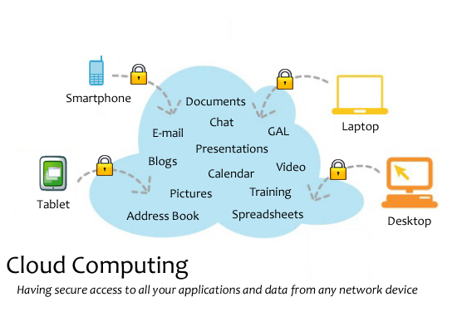
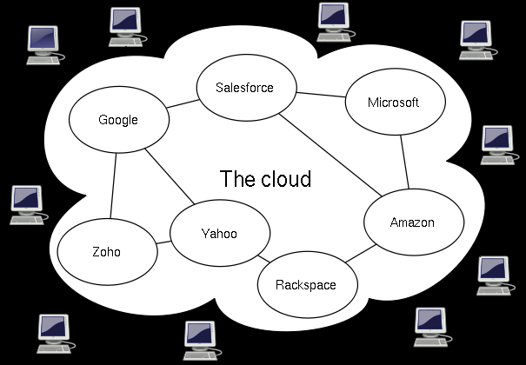
Figure 1.1.1

1.1 Overview

1.1.1 Comparisons

Cloud computing derives characteristics from, but should not be confused with:
- Autonomic computing — "computer systems capable of self-management"
- Client–server model – client–server computing refers broadly to any distributed application that distinguishes between service providers (servers) and service requesters (clients)
- Grid computing — "a form of distributed computing and parallel computing, whereby a 'super and virtual computer' is composed of a cluster of networked, loosely coupled computers acting in concert to perform very large tasks"
- Mainframe computer — powerful computers used mainly by large organizations for critical applications, typically bulk data-processing such as census, industry and consumer statistics, enterprise resource planning, and financial transaction processing.
- Utility computing — the "packaging of computing resources, such as computation and storage, as a metered service similar to a traditional public utility, such as electricity";
- Peer-to-peer – distributed architecture without the need for central coordination, with participants being at the same time both suppliers and consumers of resources (in contrast to the traditional client–server model)

1.1.2 Characteristics

Generally, cloud computing customers do not own the physical infrastructure, instead avoiding capital expenditure by renting usage from a third-party provider. They consume resources as a service and pay only for resources that they use. Many cloud-computing offerings employ the utility computing model, which is analogous to how traditional utility services (such as electricity) are consumed, whereas others bill on a subscription basis. Sharing "perishable and intangible" computing power among multiple tenants can improve utilization rates, as servers are not unnecessarily left idle (which can reduce costs significantly while increasing the speed of application development). A side-effect of this approach is that overall computer usage rises dramatically, as customers do not have to engineer for peak load limits. In addition, "increased high-speed bandwidth" makes it possible to receive the same. The cloud is becoming increasingly associated with small and medium enterprises (SMEs) as in many cases they cannot justify or afford the large capital expenditure of traditional IT. SMEs also typically have less existing infrastructure, less bureaucracy, more flexibility, and smaller capital budgets for purchasing in-house technology. Similarly, SMEs in emerging markets are typically unburdened by established legacy infrastructures, thus reducing the complexity of deploying cloud solutions.

1.1.3 Economics

Cloud computing users avoid capital expenditure (CapEx) on hardware, software, and services when they pay a provider only for what they use. Consumption is usually billed on a utility (resources consumed, like electricity) or subscription (time-based, like a newspaper) basis with little or no upfront cost. Other benefits of this approach are low barriers to entry, shared infrastructure and costs, low management overhead, and immediate access to a broad range of applications. In general, users can terminate the contract at any time (thereby avoiding return on investment risk and uncertainty), and the services are often covered by service level agreements (SLAs) with financial penalties.
According to Nicholas Carr, the strategic importance of information technology is diminishing as it becomes standardized and less expensive. He argues that the cloud computing paradigm shift is similar to the displacement of frozen water trade by electricity generators early in the 20th century.
Although companies might be able to save on upfront capital expenditures, they might not save much and might actually pay more for operating expenses. In situations where the capital expense would be relatively small, or where the organization has more flexibility in their capital budget than their operating budget, the cloud model might not make great fiscal sense. Other factors impacting the scale of any potential cost savings include the efficiency of a company's data center as compared to the cloud vendor's, the company's existing operating costs, the level of adoption of cloud computing, and the type of functionality being hosted in the cloud.
Among the items that some cloud hosts charge for are instances (often with extra charges for high-memory or high-CPU instances), data transfer in and out, storage (measured by the GB-month), I/O requests, PUT requests and GET requests, IP addresses, and load balancing. In some cases, users can bid on instances, with pricing dependent on demand for available instances.

1.1.4 Architecture

Cloud architecture, the systems architecture of the software systems involved in the delivery of cloud computing, typically involves multiple cloud components communicating with each other over application programming interfaces, usually web services. This resembles the Unix philosophy of having multiple programs each doing one thing well and working together over universal interfaces. Complexity is controlled and the resulting systems are more manageable than their monolithic counterparts.
The two most significant components of cloud computing architecture are known as the front end and the back end. The front end is the part seen by the client, i.e. the computer user. This includes the client’s network (or computer) and the applications used to access the cloud via a user interface such as a web browser. The back end of the cloud computing architecture is the ‘cloud’ itself, comprising various computers, servers and data storage devices.
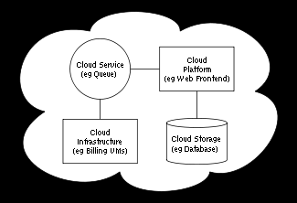
Figure 1.1.5

1.2 History

The underlying concept of cloud computing dates back to the 1960s, when John McCarthy opined that "computation may someday be organized as a public utility." Almost all the modern-day characteristics of cloud computing (elastic provision, provided as a utility, online, illusion of infinite supply), the comparison to the electricity industry and the use of public, private, government and community forms was thoroughly explored in Douglas Parkhill's 1966 book, The Challenge of the Computer Utility.
The actual term "cloud" borrows from telephony in that telecommunications companies, who until the 1990s primarily offered dedicated point-to-point data circuits, began offering Virtual Private Network (VPN) services with comparable quality of service but at a much lower cost. By switching traffic to balance utilization as they saw fit, they were able to utilize their overall network bandwidth more effectively. The cloud symbol was used to denote the demarcation point between that which was the responsibility of the provider from that of the user. Cloud computing extends this boundary to cover servers as well as the network infrastructure. The first scholarly use of the term “cloud computing” is in a 1997 lecture by Ramnath Chellappa.
Amazon played a key role in the development of cloud computing by modernizing their data centers after the dot-com bubble, which, like most computer networks, were using as little as 10% of their capacity at any one time, just to leave room for occasional spikes. Having found that the new cloud architecture resulted in significant internal efficiency improvements whereby small, fast-moving "two-pizza teams" could add new features faster and easier, Amazon initiated a new product development effort to provide cloud computing to external customers, and launched Amazon Web Service (AWS) on a utility computing basis in 2006.
In 2007, Google, IBM and a number of universities embarked on a large scale cloud computing research project. In early 2008, Eucalyptus became the first open source AWS API compatible platform for deploying private clouds. By mid-2008, Gartner saw an opportunity for cloud computing "to shape the relationship among consumers of IT services, those who use IT services and those who sell them" and observed that "[o]rganisations are switching from company-owned hardware and software assets to per-use service-based models" so that the "projected shift to cloud computing ... will result in dramatic growth in IT products in some areas and significant reductions in other areas."
In March 2010, Microsoft's CEO, Steve Ballmer, made his strongest statement of betting the company's future in the cloud by proclaiming, "For the cloud, we're all in" and further stating, "About 75 percent of our folks are doing entirely cloud based or entirely cloud inspired; a year from now that will be 90 percent."
Microsoft has also offered details on cloud services for government agencies.

1.3 Key Features

- Agility improves with users' ability to rapidly and inexpensively re-provision technological infrastructure resources.
- Cost is claimed to be greatly reduced and capital expenditure is converted to operational expenditure. This ostensibly lowers barriers to entry, as infrastructure is typically provided by a third-party and does not need to be purchased for one-time or infrequent intensive computing tasks. Pricing on a utility computing basis is fine-grained with usage-based options and fewer IT skills are required for implementation (in-house).
- Device and location independence enable users to access systems using a web browser regardless of their location or what device they are using (e.g., PC, mobile). As infrastructure is off-site (typically provided by a third-party) and accessed via the Internet, users can connect from anywhere.
- Multi-tenancy enables sharing of resources and costs across a large pool of users thus allowing for:
  - Centralization of infrastructure in locations with lower costs (such as real estate, electricity, etc.)
  - Peak-load capacity increases (users need not engineer for highest possible load-levels)
  - Utilization and efficiency improvements for systems that are often only 10–20% utilized.
- Reliability is improved if multiple redundant sites are used, which makes well designed cloud computing suitable for business continuity and disaster recovery. Nonetheless, many major cloud computing services have suffered outages, and IT and business managers can at times do little when they are affected.
- Scalability via dynamic ("on-demand") provisioning of resources on a fine-grained, self-service basis near real-time, without users having to engineer for peak loads. Performance is monitored, and consistent and loosely coupled architectures are constructed using web services as the system interface.^{[36]} One of the most important new methods for overcoming performance bottlenecks for a large class of applications is data parallel programming on a distributed data grid.
- Security could improve due to centralization of data, increased security-focused resources, etc., but concerns can persist about loss of control over certain sensitive data, and the lack of security for stored kernels. Security is often as good as or better than under traditional systems, in part because providers are able to devote resources to solving security issues that many customers cannot afford. Providers typically log accesses, but accessing the audit logs themselves can be difficult or impossible. Furthermore, the complexity of security is greatly increased when data is distributed over a wider area and / or number of devices.
- Maintenance of cloud computing applications is easier, since they don't have to be installed on each user's computer. They are easier to support and to improve since the changes reach the clients instantly.
- Metering means that cloud computing resources usage should be measurable and should be metered per client and application on a daily, weekly, monthly, and yearly basis.

1.4 Layers

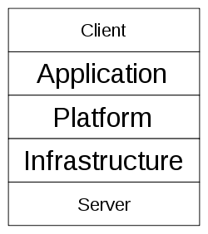
Figure 1.4

1.4.1 Client

A cloud client consists of computer hardware and/or computer software that relies on cloud computing for application delivery, or that is specifically designed for delivery of cloud services and that, in either case, is essentially useless without it. Examples include some computers, phones and other devices, operating systems and browsers.

1.4.2 Application

Cloud application services or "Software as a Service (SaaS)" deliver software as a service over the Internet, eliminating the need to install and run the application on the customer's own computers and simplifying maintenance and support. People tend to use the terms ‘SaaS’ and ‘cloud’ interchangeably, when in fact they are two different things. Key characteristics include:
- Network-based access to, and management of, commercially available (i.e., not custom) software
- Activities that are managed from central locations rather than at each customer's site, enabling customers to access applications remotely via the Web
- Application delivery that typically is closer to a one-to-many model (single instance, multi-tenant architecture) than to a one-to-one model, including architecture, pricing, partnering, and management characteristics
- Centralized feature updating, which obviates the need for downloadable patches and upgrades.

1.4.3 Platform

Cloud platform services or "Platform as a Service (PaaS)" deliver a computing platform and/or solution stack as a service, often consuming cloud infrastructure and sustaining cloud applications. It facilitates deployment of applications without the cost and complexity of buying and managing the underlying hardware and software layers.

1.4.4 Infrastructure

Cloud infrastructure services, also known as "Infrastructure as a Service (IaaS)", delivers computer infrastructure - typically a platform virtualization environment - as a service. Rather than purchasing servers, software, data-center space or network equipment, clients instead buy those resources as a fully outsourced service. Suppliers typically bill such services on a utility computing basis and amount of resources consumed (and therefore the cost) will typically reflect the level of activity. IaaS evolved from virtual private server offerings.

1.4.5 Server

The servers layer consists of computer hardware and/or computer software products that are specifically designed for the delivery of cloud services, including multi-core processors, cloud-specific operating systems and combined offerings.

1.5 Deployment Models

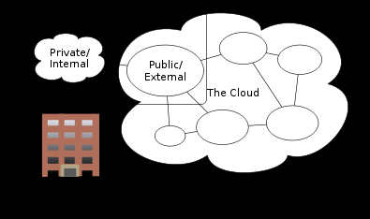
Figure 1.5

1.5.1 Public Cloud

Public cloud or external cloud describes cloud computing in the traditional mainstream sense, whereby resources are dynamically provisioned on a fine-grained, self-service basis over the Internet, via web applications/web services, from an off-site third-party provider who bills on a fine-grained utility computing basis.

1.5.2 Community Cloud

A community cloud may be established where several organizations have similar requirements and seek to share infrastructure so as to realize some of the benefits of cloud computing. With the costs spread over fewer users than a public cloud (but more than a single tenant) this option is more expensive but may offer a higher level of privacy, security and/or policy compliance. Examples of community cloud include Google's "Gov Cloud".

1.5.3 Hybrid Cloud

There is some confusion over the term "Hybrid" when applied to the cloud - a standard definition of the term "Hybrid Cloud" has not yet emerged. The term "Hybrid Cloud" has been used to mean either two separate clouds joined together (public, private, internal or external), or a combination of virtualized cloud server instances used together with real physical hardware. The most correct definition of the term "Hybrid Cloud" is probably the use of physical hardware and virtualized cloud server instances together to provide a single common service. Two clouds that have been joined together are more correctly called a "combined cloud".
A combined cloud environment consisting of multiple internal and/or external providers "will be typical for most enterprises". By integrating multiple cloud services users may be able to ease the transition to public cloud services while avoiding issues such as PCI compliance.
Another perspective on deploying a web application in the cloud is using Hybrid Web Hosting, where the hosting infrastructure is a mix between Cloud Hosting and Managed dedicated servers - this is most commonly achieved as part of a web cluster in which some of the nodes are running on real physical hardware and some are running on cloud server instances.
A hybrid storage cloud uses a combination of public and private storage clouds. Hybrid storage clouds are often useful for archiving and backup functions, allowing local data to be replicated to a public cloud.

1.5.4 Private Cloud

Douglas Parkhill first described the concept of a "Private Computer Utility" in his 1966 book The Challenge of the Computer Utility. The idea was based upon direct comparison with other industries (e.g. the electricity industry) and the extensive use of hybrid supply models to balance and mitigate risks.
Private cloud and internal cloud have been described as neologisms, however the concepts themselves pre-date the term cloud by 40 years. Even within modern utility industries, hybrid models still exist despite the formation of reasonably well-functioning markets and the ability to combine multiple providers.
Some vendors have used the terms to describe offerings that emulate cloud computing on private networks. These (typically virtualization automation) products offer the ability to deliver some benefits of cloud computing whilst mitigating someof the pitfalls. These offerings capitalize on data security, corporate governance, and reliability concerns during this time of transition from a product to a functioning service-based industry supported by competitive marketplaces.
Private clouds have attracted criticism because users "still have to buy, build, and manage them" and thus do not benefit from lower up-front capital costs and less hands-on management, essentially "[lacking] the economic model that makes cloud computing such an intriguing concept"

1.6 Cloud Storage

Cloud Storage is a model of networked computer data storage where data is stored on multiple virtual servers, generally hosted by third parties, rather than being hosted on dedicated servers. Hosting companies operate large data centers; and people who require their data to be hosted buy or lease storage capacity from them and use it for their storage needs. The data center operators, in the background, virtualize the resources according to the requirements of the customer and expose them as virtual servers, which the customers can themselves manage. Physically, the resource may span across multiple servers.

1.7 The Inter-Cloud

The Intercloud is an interconnected global "cloud of clouds" and an extension of the Internet "network of networks" on which it is based. The term was first used in the context of cloud computing in 2007 when Kevin Kelly stated that "eventually we'll have the intercloud, the cloud of clouds. This Intercloud will have the dimensions of one machine comprising all servers and attendant cloudbooks on the planet.". It became popular in 2009 and has also been used to describe the datacenter of the future.
The Intercloud scenario is based on the key concept that each single cloud does not have infinite physical resources. If a cloud saturates the computational and storage resources of its virtualization infrastructure, it could not be able to satisfy further requests for service allocations sent from its clients. The Intercloud scenario aims to address such situation, and in theory, each cloud can use the computational and storage resources of the virtualization infrastructures of other clouds. Such form of pay-for-use may introduce new business opportunities among cloud providers if they manage to go beyond theoretical framework. Nevertheless, the Intercloud raises many more challenges than solutions concerning cloud federation, security, interoperability, QoS, vendor's lock-ins, trust, legal issues, monitoring and billing.
The concept of a competitive utility computing market which combined many computer utilities together was originally described by Douglas Parkhill in his 1966 book, the "Challenge of the Computer Utility". This concept has been subsequently used many times over the last 40 years and is identical to the Intercloud.

1.8 Issues

1.8.1 Privacy

The Cloud model has been criticized by privacy advocates for the greater ease in which the companies hosting the Cloud services control, and thus, can monitor at will, lawfully or unlawfully, the communication and data stored between the user and the host company. Instances such as the secret NSA program, working with AT&T, and Verizon, which recorded over 10 million phone calls between American citizens, causes uncertainty among privacy advocates, and the greater powers it gives to telecommunication companies to monitor user activity.^{[72]} While there have been efforts (such as US-EU Safe Harbor) to "harmonize" the legal environment, providers such as Amazon still cater to major markets (typically the United States and the European Union) by deploying local infrastructure and allowing customers to select "availability zones."

1.8.2 Compliance

In order to obtain compliance with regulations including FISMA, HIPAA and SOX in the United States, the Data Protection Directive in the EU and the credit card industry's PCI DSS, users may have to adopt community or hybrid deployment modes which are typically more expensive and may offer restricted benefits. This is how Google is able to "manage and meet additional government policy requirements beyond FISMA" and Rackspace Cloud are able to claim PCI compliance. Customers in the EU contracting with Cloud Providers established outside the EU/EEA have to adhere to the EU regulations on export of personal data.
Many providers also obtain SAS 70 Type II certification (e.g. Amazon, Salesforce.com, Google and Microsoft), but this has been criticised on the grounds that the hand-picked set of goals and standards determined by the auditor and the auditee are often not disclosed and can vary widely. Providers typically make this information available on request, under non-disclosure agreement

1.8.3 Legal

In March 2007, Dell applied to trademark the term "cloud computing" (U.S. Trademark 77,139,082) in the United States. The "Notice of Allowance" the company received in July 2008 was canceled in August, resulting in a formal rejection of the trademark application less than a week later. Since 2007, the number of trademark filings covering cloud computing brands, goods and services has increased at an almost exponential rate. As companies sought to better position themselves for cloud computing branding and marketing efforts, cloud computing trademark filings increased by 483% between 2008 and 2009. In 2009, 116 cloud computing trademarks were filed, and trademark analysts predict that over 500 such marks could be filed during 2010.
Other legal cases may shape the use of cloud computing by the public sector. On October 29, 2010, Google filed a lawsuit against the U.S. Department of Interior, which opened up a bid for software that required that bidders use Microsoft's Business Productivity Online Suite. Google sued, calling the requirement "unduly restrictive of competition." Scholars have pointed out that, beginning in 2005, the prevalence of open standards and open source may have an impact on the way that public entities choose to select vendors.

1.8.4 Open Source

Open source software has provided the foundation for many cloud computing implementations. In November 2007, the Free Software Foundation released the Affero General Public License, a version of GPLv3 intended to close a perceived legal loophole associated with free software designed to be run over a network.

1.8.5 Open Standards

Most cloud providers expose APIs which are typically well-documented (often under a Creative Commons license) but also unique to their implementation and thus not interoperable. Some vendors have adopted others' APIs and there are a number of open standards under development, including the OGF's Open Cloud Computing Interface. The Open Cloud Consortium (OCC) is working to develop consensus on early cloud computing standards and practices.

1.8.6 Security

The relative security of cloud computing services is a contentious issue which may be delaying its adoption. Some argue that customer data is more secure when managed internally, while others argue that cloud providers have a strong incentive to maintain trust and as such employ a higher level of security. Cloud computing, however, does have security and privacy concerns at present.
The Cloud Security Alliance is a non-profit organization formed to promote the use of best practices for providing security assurance within Cloud Computing.

1.8.7 Availability and Performance

In addition to concerns about security, businesses are also worried about acceptable levels of availability and performance of applications hosted in the cloud.
There are also concerns about a cloud provider shutting down for financial or legal reasons, which has happened in a number of cases.

1.8.8 Sustainability and Siting

Although cloud computing is often assumed to be a form of "green computing", there is as of yet no published study to substantiate this assumption. Siting the servers affects the environmental effects of cloud computing. In areas where climate favors natural cooling and renewable electricity is readily available, the environmental effects will be more moderate. Thus countries with favorable conditions, such as Finland, Sweden and Switzerland, are trying to attract cloud computing data centers.
SmartBay, marine research infrastructure of sensors and computational technology, is being developed using Cloud computing, an emerging approach to shared infrastructure in which large pools of systems are linked together to provide IT services.

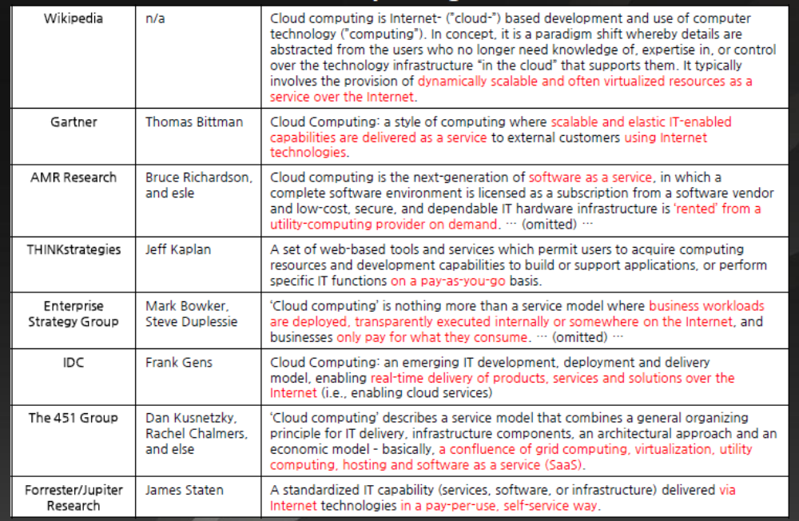
Table 1.8.8

Chapter 2
An Introduction to Overlay Network

An overlay network is a computer network which is built on top of another network. Nodes in the overlay can be thought of as being connected by virtual or logical links, each of which corresponds to a path, perhaps through many physical links, in the underlying network. For example, distributed systems such as cloud computing, peer-to-peer networks, and client-server applications are overlay networks because their nodes run on top of the Internet. The Internet was built as an overlay upon the telephone network.

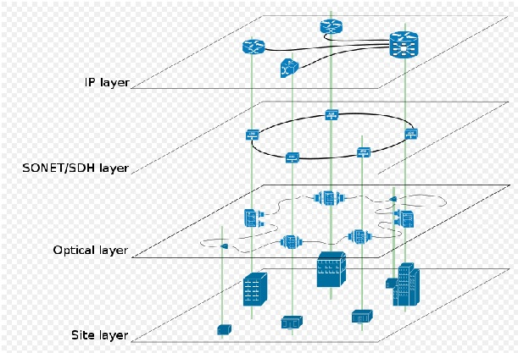
Figure 2.1.1

2.1 Uses of Overlay Networks

2.1.1 Uses in Telecommunication

Overlay networks are used in telecommunication since the availability of digital circuit switching equipments and optical fiber. Telecommunication transport networks and IP networks (that combined make up the broader Internet) are all overlaid with at least an optical layer, a transport layer and an IP or circuit layers (in the case of the PSTN).
Enterprise private networks were first overlaid on telecommunication networks such as frame relay and Asynchronous Transfer Mode packet switching infrastructures but migration from these (now legacy) infrastructures to IP based MPLS networks and virtual private networks started (2001~2002).
From a physical standpoint overlay networks are quite complex (see Figure 1) as they combine various logical layers that are operated and built by various entities (businesses, universities, government etc) but they allow separation of concerns (and healthy business competition) that over time permitted the build up of a broad set of services that could not have been proposed by a single telecommunication operator overwise (ranging from broadband Internet access, voice over IP or IPTV, competitive telecom operators etc)

2.1.2 Uses over the Internet

Nowadays the Internet is the basis for more overlaid networks than can be constructed in order to permit routing of messages to destinations not specified by an IP address. For example, distributed hash tables can be used to route messages to a node having a specific logical address, whose IP address is not known in advance.
Overlay networks have also been proposed as a way to improve Internet routing, such as through quality of service guarantees to achieve higher-quality streaming media. Previous proposals such as IntServ, DiffServ, and IP multicast have not seen wide acceptance largely because they require modification of all routers in the network. On the other hand, an overlay network can be incrementally deployed on end-hosts running the overlay protocol software, without cooperation from ISPs. The overlay has no control over how packets are routed in the underlying network between two overlay nodes, but it can control, for example, the sequence of overlay nodes a message traverses before reaching its destination.
For example, Akamai Technologies manages an overlay network which provides reliable, efficient content delivery (a kind of multicast). Academic research includes End System Multicast and Overcast for multicast; RON (Resilient Overlay Network) for resilient routing; and OverQoS for quality of service guarantees, among others.
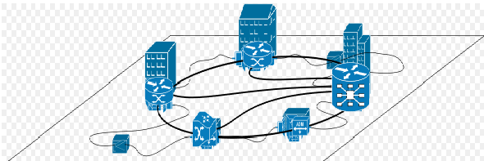
Figure 2.1.2
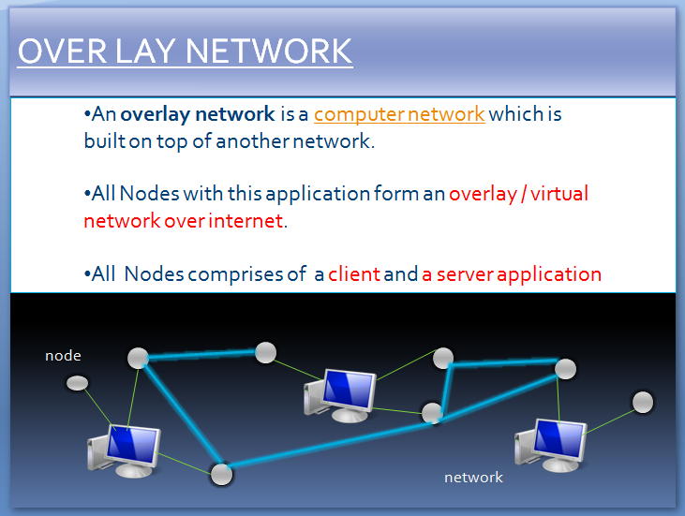
Figure 2.1.3

Chapter 3
An Introduction to Software as a Service (SaaS)

Software as a service (SaaS, typically pronounced [sæs]), sometimes referred to as "software on demand," is software that is deployed over the internet and/or is deployed to run behind a firewall on a local area network or personal computer. With SaaS, a provider licenses an application to customers either as a service on demand, through a subscription, in a "pay-as-you-go" model, or (increasingly) at no charge. This approach to application delivery is part of the utility computing model where all of the technology is in the "cloud" accessed over the Internet as a service.
Advantages
- Pay per use
- Anytime, anywhere accessibility
- Pay as you go
- Instant scalability
- Security
- Reliability
- APIs
SaaS was initially widely deployed for sales force automation and Customer Relationship Management (CRM). Now it has become commonplace for many business tasks, including accounting software, computerized billing, ERP software, invoicing, human resource management, financials, content management, collaboration, document management, and service desk management.
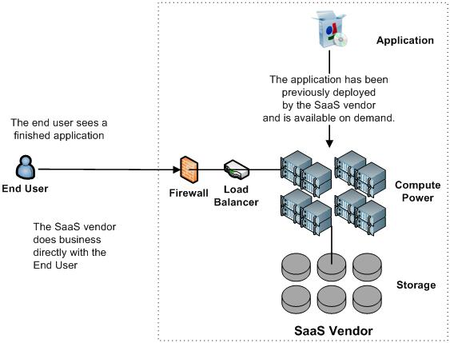Figure 3.1

3.1 History

Software as a service's acronym, SaaS, first appears in an article called "Strategic Backgrounder: Software as a Service." It was published in February 2001 by the Software & Information Industry's (SIIA) eBusiness Division. This 18 page document is one of the most complete essays pertaining to SaaS available today. SIIA developed the backgrounder to analyze the current state of the SaaS market and its near term prospects, and to provide insight for its members who may be profoundly impacted by changes implied in the SaaS mode. Software as a service is essentially an extension of the idea of the Application Service Provider (ASP) model.
One of the first SaaS applications was SiteEasy, a web-site-in-a-box for small businesses, that launched in 1998 at Siteeasy.com. Developed by Atlanta-based firm WebTransit (now defunct) by Gary Troutman and Drew Wilkins, SiteEasy was sold on a subscription basis to its first customer in the Fall, 1998.
Loudcloud, founded in 1999 by Marc Andreessen, was one of the first to attempt to commercialize Software as a Service computing with an Infrastructure as a Service model. The technology also was called "ASP's" or Application Service Providers, under the terminology of the day. Loudcloud changed its name to Opsware after selling the operations side of the business to EDS in 2002, and HP acquired Opsware in 2007 and EDS in 2008. HP now offers the SaaS originally developed by Loudcloud as HP Software-as-a-Service.

3.2 Key Characteristics

SaaS characteristics include:
- Network-based access to, and management of, commercially available software
- Activities managed from central locations rather than at each customer's site, enabling customers to access applications remotely via the Web
- Application delivery typically closer to a one-to-many model (single instance, multi-tenant architecture) than to a one-to-one model, including architecture, pricing, partnering, and management characteristics
- Centralized feature updating, which obviates the need for end-users to download patches and upgrades.
- Frequent integration into a larger network of communicating software—either as part of a mashup or a plugin to a platform as a service
(Service oriented architecture is naturally more complex than traditional models of software deployment.)
SaaS providers generally price applications on a per-user basis and/or per business basis, sometimes with a relatively small minimum number of users and often with additional fees for extra bandwidth and storage. SaaS revenue streams to the vendor are therefore lower initially than traditional software license fees, but are also recurring, and therefore viewed as more predictable, much like maintenance fees for licensed software.
Some SaaS applications are free to the user, with revenue being derived from alternate sources such as advertising, or upgrade fees for enhanced functionality (often referred to as "freemium"). Examples of free SaaS applications include large players such as Gmail and Google Docs, as well as smaller providers like Wave Accounting (free accounting) and Freshbooks (freemium time tracking and invoicing).
In addition to characteristics mentioned above, SaaS sometimes provides:
- More feature requests from users, since there is frequently no marginal cost for requesting new features
- Faster new feature releases, since the entire community of users benefits
- Embodiment of recognized best practices, since the user community drives the software publisher to support best practice.

3.2.1 Configuration, customization

Driven by a multi-tenancy architecture, SaaS applications tend to not support what is traditionally known as application customization. In other words, unlike traditional enterprise software, a single customer cannot alter the source code of the application, its database schema or its GUI. Instead, multi-tenant applications are designed to support application configuration; i.e., a set of configuration options (a.k.a., parameters) that affect its functionality and look-and-feel. Each customer may have its own settings (or: parameter values) for the configuration options. The application can be customized to the degree it was designed for based on a set of predefined configuration options.
For example: to support customers' common need to change an application's look-and-feel so that the application appears to be having the customer's brand (or—if so desired—co-branded), many SaaS applications let customers provide (through a self service interface or by working with application provider staff) a custom logo and sometimes a set of custom colors. The customer cannot, however, change the page layout unless such an option was designed for.

3.2.2 Accelerated feature delivery

SaaS applications are often updated more frequently than traditional software^{[9]}, in many cases on a weekly or monthly basis. This is enabled by several factors:
- The application is hosted centrally, so new releases can be put in place without requiring customers to physically install new software.
- The application only has a single configuration, making development testing faster.
- The application vendor has access to all customer data, expediting design and regression testing.
- The solution provider has access to user behavior within the application (usually via web analytics), making it easier to identify areas worthy of improvement.
Accelerated feature delivery is further enabled by agile software development methodologies^{[10]}. Such methodologies, which have evolved in the mid-1990's, provide a set of software development tools and practices to support frequent software releases.

3.2.3 Open integration protocols

Since SaaS applications cannot access a company's internal systems (databases or internal services), they predominantly offer integration protocols and application programming interfaces (APIs) that operate over a wide area network. Typically, these are protocols based on HTTP, REST, SOAP and JSON.
The ubiquity of SaaS applications and other Internet services and the standardization of their API technology has spawned development of mashups, which are lightweight applications that combine data, presentation and functionality from multiple services, creating a compound service. Mashups further differentiate SaaS applications from on-premises software as the latter cannot be easily integrated outside a company's firewall..

3.2.4 Collaborative (and "social") functionality

Inspired by the success of online social networks and other so-called web 2.0 functionality, many SaaS applications offer features that let its users collaborate and share information.
For example, many project management applications delivered in the SaaS model offer—in addition to traditional project planning functionality—collaboration features letting users comment on tasks and plans and share documents within and outside an organization. Several other SaaS applications let users vote on and offer new feature ideas.
While some collaboration-related functionality is also integrated into on-premises software, (implicit or explicit) collaboration between users of different customers is only possible with centrally-hosted software.

3.3 Benefits

- Save money by not having to purchase servers or other software to support use.
- Faster Implementation. Customers can deploy SaaS services/products within hours rather than weeks or months.
- Focus Budgets on competitive advantage rather than infrastructure (Low Total Cost of Ownership)
- Monthly obligation rather than up front capital cost
- Reduced need to predict scale of demand and infrastructure investment up front as available capacity matches demand
- Multi-Tenant efficiency
- Flexibility and scalability
- Reliability

3.4 Implementation

One of the companies that sells that kind of service classifies SaaS into four "maturity levels," whose key attributes are configurability, multi-tenant efficiency, and scalability. Each level is distinguished from the previous one by the addition of one of those three attributes:
- Level 1 - Ad-hoc/custom: Each customer has a customized version of the hosted application that runs as its own instance on the host's servers. Migrating a traditional non-networked or client–server application to this level of SaaS typically requires the least development effort, and reduces operating costs by consolidating server hardware and administration.
- Level 2 - Configurable: This adds greater program flexibility through configurable metadata, so many customers use separate instances of the same application code. This lets the vendor meet different customer needs through detailed configuration options, while simplifying common code base maintenance and updating.
- Level 3 - Configurable, multi-tenant-efficient: This adds multi-tenancy to the second level, so a single program instance serves all customers. This enables more efficient server resource use without apparent difference to the end user, but ultimately faces scalability limits.
- Level 4 - Scalable, configurable, multi-tenant-efficient: The fourth and final SaaS maturity level adds scalability through a multitier architecture that supports a load-balanced farm of identical application instances that run on a variable number of servers. The provider can adjust system capacity to match demand by adding or removing servers without further altering the software architecture.
SaaS architectures may also use virtualization, either in addition to multi-tenancy, or in place of it.^{[10]} A principal virtualization benefit is that it can increase system capacity without additional programming. On the other hand, much programming may be required to construct a more efficient multi-tenant application. Combining multi-tenancy and virtualization provides still greater flexibility to tune the system for optimal performance.^{[11]} In addition to full operating system-level virtualization, other virtualization techniques applied to SaaS include application virtualization and virtual appliances.
SaaS application development may use various types of software components and frameworks. These tools can reduce time-to-market and the cost of converting a traditional on-premise software product or building and deploying a new SaaS solution. Examples include components for subscription management, grid computing software, web application frameworks, and complete SaaS platform products.

3.5 SaaS and SOA

Much like other software, SaaS can also take advantage of Service Oriented Architecture to let software applications communicate with each other. Each software service can act as a service provider, exposing its functionality to other applications via public brokers, and can also act as a service requester, incorporating data and functionality from other services. Enterprise Resource Planning (ERP) Software providers leverage SOA in building their SaaS offerings.
Software as a secure service (SaSS) is a variation of SaaS that provides security in the link to the service, content storage on the service, and non-proprietary format data backups and restores of data stored on the service.

3.6 Adoption

3.6.1 Drivers

A traditional rationale for outsourcing IT systems involves applying economies of scale to application operation, i.e., an outside service provider can offer better, cheaper, more reliable applications. SaaS-based application use has grown dramatically. A Gartner survey in July 2009 found that customers are "somewhat satisfied". Several important changes to the way people work have facilitated this rapid acceptance:
- Fast, low-cost broadband is available.
- Computers have become widespread—most information workers have at least basic computer skills.
- Computing has become a commodity. In the past, corporate mainframes were jealously guarded as strategic advantages. More recently, applications were viewed as strategic. Today, people know it’s the business processes and the data itself (customer records, workflows, pricing information) that matters. Computing and application licenses are cost centers, and as such, they’re suitable for cost reduction and outsourcing. The adoption of SaaS could also drive Internet-scale to become a commodity.
- Insourcing IT systems requires expensive overhead including salaries, health care, liability, and physical building space.
- Applications have tended to standardize. With notable, industry-specific exceptions, most people spend most of their time using standardized applications. An expense-reporting page, an applicant screening tool, a spreadsheet, or an e-mail system are all sufficiently ubiquitous and well understood that most users can switch from one system to another easily. This is evident from the number of web-based calendaring, spreadsheet, and e-mail systems that have emerged in recent years.
- Parametric applications are usable. In older applications, one could often only change a workflow by modifying the code. In more recent applications, particularly web-based ones, significantly new applications can be created from parameters and macros. This allows organizations to create different kinds of business logic on a common application platform. Many SaaS providers allow a wide range of customization within a basic set of functions.
- A specialized software provider can target global markets. A company that made software for human resource management at boutique hotels might once have had a hard time finding enough of a market to sell its applications. But a hosted application can instantly reach the entire market, making specialization within a vertical market not only possible, but preferable. This in turn means SaaS providers can often deliver products that meet specific market needs better than traditional "shrinkwrap" applications.
- Web systems demonstrate reliability. Despite sporadic outages and slow-downs, most people are willing to use the public Internet, the Hypertext Transfer Protocol and the TCP/IP stack to deliver business functions to end users.
- Security is sufficiently well trusted and transparent. With the broad adoption of SSL, organizations have a way of reaching their applications without the complexity and burden of end-user configurations or VPNs.
- Enablement technology (tools, libraries, etc,) is available. According to IDC, organizations developing enablement technology that allow other vendors to quickly build SaaS applications will play an important role in driving the adoption of SaaS. Because of SaaS' relative infancy, many companies have either built enablement tools or platforms or are in the process of engineering enablement tools or platforms. A Saugatuck study shows the industry will most likely converge to three or four enablers that will act as SaaS Integration Platforms (SIPs).
- Wide-area network bandwidth has grown drastically, following Moore's Law (more than 100% increase each 24 months), and is about to reach slow local networks bandwidths. Added to network quality improvement, this has driven people and companies to trustfully access remote locations and applications with low latencies and acceptable speeds.
- SaaS has "democratized" software, allowing small and medium businesses to access functionality formerly the domain of large enterprises. Many analytical software tools have been released as SaaS applications on a monthly subscription basis.
- SaaS facilitates data aggregation. Instead of collecting data from multiple data sources with different database schemas, all data for all customers is stored in a single database schema (i.e., multi-tenant). This simplifies running queries across customers, mining data, and looking for trends.
- The rise of third-party SaaS data escrow services has reduced some security concerns by allowing application data to be held with an independent third party.

3.6.2 Sales Channels

With products focus on the mid market, direct selling can become an expensive undertaking. SaaS companies seek alternatives by selling through value-added resellers (VARs), Managed Service Providers (MSPs), Master Managed Service Providers (MMSPs), and similar alliance partners. However, since SaaS is not only a different delivery mechanism, but a different business model and different technology, selling through channels has its own challenges.

3.6.3 Pricing

Unlike traditional software, conventionally sold as a perpetual license with an associated up-front fee (and, typically, smaller ongoing support fees), SaaS providers generally price applications using a subscription fee, most commonly a monthly fee or an annual fee. Consequently, the initial setup cost for SaaS is typically lower than the equivalent enterprise software. SaaS vendors typically price their applications based on some usage parameters, such as the number of users ("seats") using the application. However, because in a SaaS environment customers' data resides with the SaaS vendor, opportunities also exist to charge per transaction, event, or other unit of value.
The relatively low cost for user provisioning (i.e., setting up a new customer) in a multi-tenant environment enables some SaaS vendors to offer applications using the freemium model. In this model, a free service is made available with limited functionality or scope, and fees are charged for enhanced functionality or larger scope. Some other SaaS applications are completely free to users, with revenue being derived from alternate sources such as advertising.
A key driver of SaaS growth is SaaS vendors' ability to provide a price that is competitive with on-premises software. This is consistent with the traditional rationale for outsourcing IT systems, which involves applying economies of scale to application operation, i.e., an outside service provider may be able offer better, cheaper, more reliable applications.

3.6.4 User Satisfaction

Gartner's 2008 survey of 333 enterprises in the US and UK found a low level of approval from customers, describing overall satisfaction levels as "lukewarm." Respondents who decided against SaaS cited high service cost, integration difficulty, and technical requirements. A recent report from Forrester, “The ROI of Software-As-A-Service,” examined a range of companies that chose SaaS solutions and found that SaaS does result in long-term value. Companies interviewed for the report cited several reasons for their ROI of SaaS:
- Rapid deployment
- Increased user adoption
- Reduced support needs
- Lower implementation and upgrade costs

3.6.5 Architecture

The vast majority of SaaS solutions is based on a multi-tenant architecture. With this model, a single version of the application, with a single configuration (hardware, network, operating system), is used for all customers ("tenants"). To support scalability, the application is installed on multiple machines (called horizontal scaling). In some cases, a second version of the application is set up to offer a select group of customers with access to pre-release versions of the applications (e.g., a beta version) for testing purposes. This is contrasted with traditional software, where multiple physical copies of the software—each potentially of a different version, with a potentially different configuration, and oftentimes customized—are installed across the various customer sites.
While an exception rather the norm, some SaaS solutions do not use multi-tenancy, or use other mechanisms—such as virtualization—to cost-effectively manage a large number of customers in place of multi-tenancy.^{[7]} Whether multi-tenancy is a necessary component for software-as-a-service is a topic of controversy.^{[8]}

Chapter 4
An Introduction to Our Project

This Project is an attempt to share resources that in this case are Software on a cloud.
An adhoc overlay network is created when a node-server is started. Every node carries a list nearest nodes. Nearest nodes are identified on the basis of cost associated to them.

4.1 Cost

These cost are determined by sending an icmp packet, and calculating the round trip time.
These associated cost of neighbor nodes are stored on each node along with their address. They are sorted according to the cost. Software request is send to each node, according to the sorted sequence.

4.2 Sender

When a particular Software is not available at the client machine, request can be sent to the cloud. The request is routed within the cloud. If the required software is found available on some server in the cloud, the given input is processed an d the output is generated. The generated output is
send back to the requesting client.
Sender node carry a list of neighbor or least cost nodes in the cloud. Each node is picked from the sorted list. Request is sen to each node one by one. If the software is found available on any of the server, process exits, No further request is sen to any node.
Every time a s/w is found unavailable on a server, a nack is send back to client. Further, the same request is forwarded to its neighboring node. This way the request get routed within the whole cloud.
When a positive response for the routed request is received from some server within the cloud,
the neighbor nodes list is updated.

4.3 Reciever

Any Node-server within the cloud acts as a Reciever. It is always in the waiting state, waiting for a request. When a request is received, a new process is forked to process that request.
Request message is read and parsed and stored in a data structure. Attributes of request is determined.

4.3.1 Primary Request

The primary request is one that is received directly from the sender, ie the server must be listed within the least-cost-node list of sender. If the request is primary, then the software is checked for availability. If found available an acknowledgement is send back . The s/w is executed on the server side, and the output is generated. This output is written back to the requesting client. On the sender , the output is presented to the end user by formatting it .

4.3.2 Secondary Request

The Routed request within the cloud that is received by some node-server is the secondary request. The source address (ie, the address of originally requesting client), is read and a connection is established with the source sender. Sender thus obtain the the address of an available node within the cloud. It updates its least-cost-node list. Software is executed on the node-server. The output is send back , which is presented to the end user.

5.5 Presentation

The Software request when executed on a node-server generates some output. This output need to be communicated to the sender node. Further the output also need to be presented to the end user.
At the node-server(available reciever) the output generated is formatted into a valid format according to the type of software. Since different softwares executes differently and generates output in different format. Thus for every type of Software there is implemented a unique presentation layer. This
formatted output file is written on the requesting sender.
On the sender side, the output is formatted into some presentable format. In this case, it is converted into a HTML format. Output is presented to the end user, in HTML document through a web browser.

5.5 Data Structure

A Bucket data structure is used to store least-cost-node list (neighbor node) list at each node. An array is maintained with its index value as the cost of nodes. At each index a linked list of nodes is built ,with corresponding cost value.
A linked list is maintained to store the list of all available software at each node.

5.6 Shared Software-

- Simple applications like- addition, subtraction, multiplication,division,
- gcc compiler and java compiler.

Chapter 5

Design and Implementation

The goal of the design phase is to transform the requirement specification into a structure that is suitable for implementation in some programming language. The following items must be designed during the design phase:

- Different modules required to implement the design solution.

- Control relationship among the identified modules.

- Interface among different modules.

- Algorithms required implementing the individual module.

5.1 Data Flow Diagrams

The data flow diagram is a pictorial way to represent the control flow of the program. It is a neat way to show the logical flow of the functions of various modules that together make up the program. It is a healthy way to remember and explain how the algorithms work for the given program. The diagram comprises closed bounded figures representing process/functional entities and arrows representing the control flow.

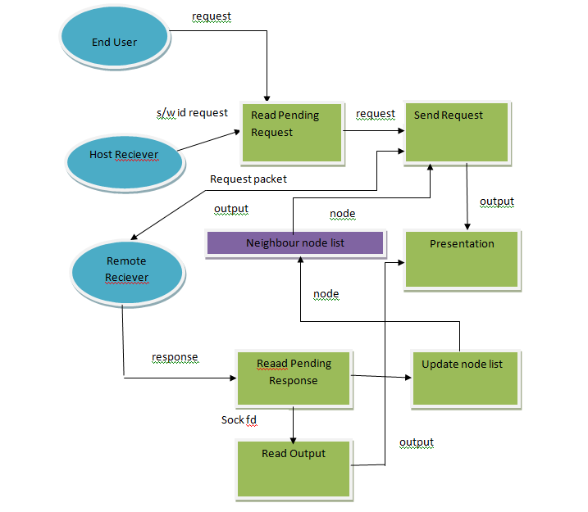
Figure 5.1.1: Sender DFD
Figure 5.1.2: Receiver DFD

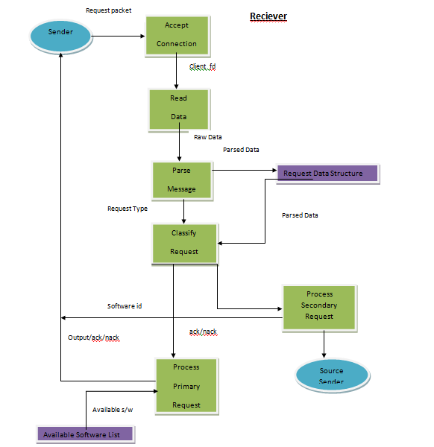

5.2 System Architecture
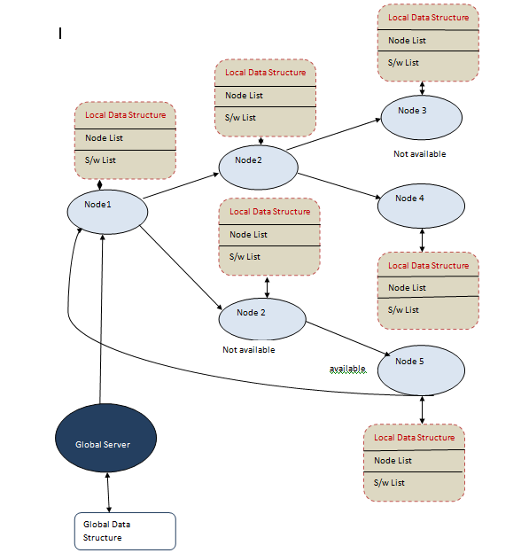

5.3 Algorithm

5.3.1 Sender Algorithm
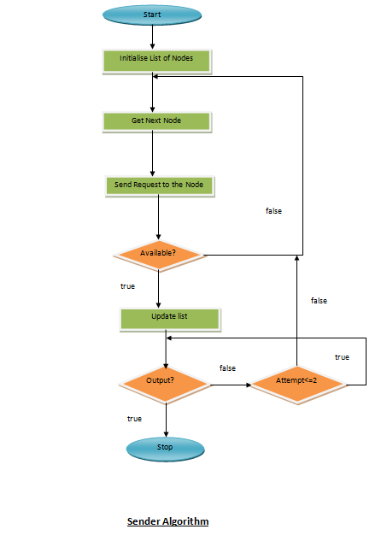
5.3.2 Receiver Algorithm
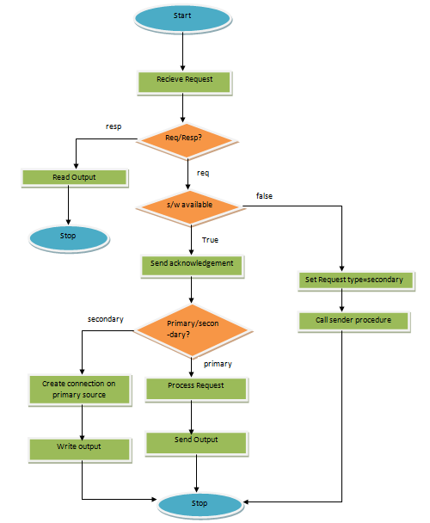
Figure 5.3.2

5.4 Packets

5.4.1 Sender Packet
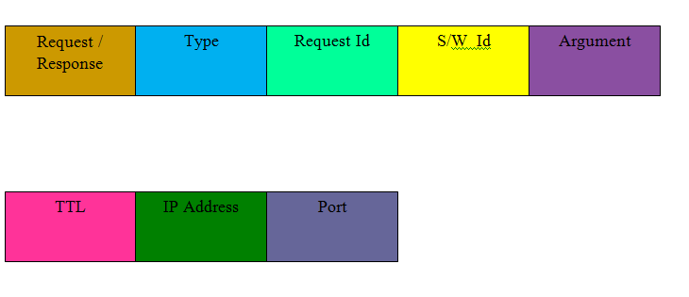

5.4.2 Receiver Packet

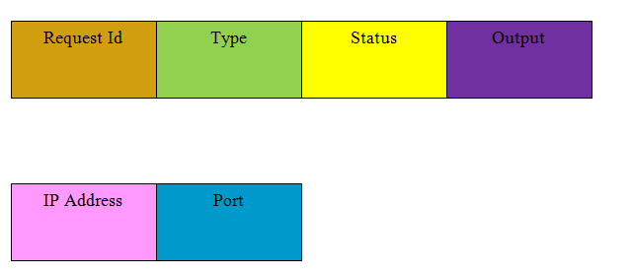

5.5 Software Sharing Over Private Cloud

This Project is an attempt to share resources that in this case are Software on a cloud.
An adhoc overlay network is created when a node-server is started. Every node carries a list nearest nodes. Nearest nodes are identified on the basis of cost associated to them.

Cost- These cost are determined by sending an icmp packet, and calculating the round trip time.
These associated cost of neighbor nodes are stored on each node along with their address. They are sorted according to the cost. Software request is send to each node, according to the sorted sequence.

5.5.1 Sender

When a particular Software is not available at the client machine, request can be sent to the cloud. The request is routed within the cloud. If the required software is found available on some server in the cloud, the given input is processed an d the output is generated. The generated output is
send back to the requesting client.

Sender node carry a list of neighbor or least cost nodes in the cloud. Each node is picked from the sorted list. Request is sen to each node one by one. If the software is found available on any of the server, process exits, No further request is sen to any node.

Every time a s/w is found unavailable on a server, a nack is send back to client. Further, the same request is forwarded to its neighboring node. This way the request get routed within the whole cloud.

When a positive response for the routed request is received from some server within the cloud,
the neighbor nodes list is updated.

5.5.2 Receiver

Any Node-server within the cloud acts as a Receiver. It is always in the waiting state, waiting for a request. When a request is received, a new process is forked to process that request.

Request message is read and parsed and stored in a data structure. Attributes of request is determined.

Primary Request

The primary request is one that is received directly from the sender, ie the server must be listed within the least-cost-node list of sender. If the request is primary, then the software is checked for availability. If found available an acknowledgement is send back . The s/w is executed on the server side, and the output is generated. This output is written back to the requesting client. On the sender , the output is presented to the end user by formatting it .

Secondary Request

The Routed request within the cloud that is received by some node-server is the secondary request. The source address (ie, the address of originally requesting client), is read and a connection is established with the source sender. Sender thus obtain the the address of an available node within the cloud. It updates its least-cost-node list. Software is executed on the node-server. The output is send back , which is presented to the end user.

5.5.3 Presentation

The Software request when executed on a node-server generates some output. This output need to be communicated to the sender node. Further the output also need to be presented to the end user.

At the node-server(available receiver) the output generated is formatted into a valid format according to the type of software. Since different softwares executes differently and generates output in different format. Thus for every type of Software there is implemented a unique presentation layer. This
Formatted output file is written on the requesting sender.

On the sender side, the output is formatted into some presentable format. In this case, it is converted into a HTML format. Output is presented to the end user, in HTML document through a web browser.

5.5.4 Data Structure

A Bucket data structure is used to store least-cost-node list (neighbor node) list at each node. An array is maintained with its index value as the cost of nodes. At each index a linked list of nodes is built ,with corresponding cost value.

A linked list is maintained to store the list of all available software at each node.

5.5.5 Shared Software

Simple applications like- addition, subtraction, multiplication, division,

GCC compiler and java compiler.

Chapter 6

Advantages and Limitations of SaaS
Software as a service (SaaS) is seen by many as being an increasingly important tool for small businesses. It is a relatively new concept that allows you to ‘consume’ software on a subscription basis, instead of the traditional model of continually purchasing an expensive updated version every few years (in the style of Microsoft Office and others).
6.1 Advantages
6.1.1 No Installation Required
The beauty of SaaS is that it does not require you to install anything onto your computer. It will run straight from your browser window when you log into your SaaS service provider’s website. This means you will not have to spend hours sat in front of your computer with a pile of installation CD’s trying to start working with the new software you have purchased! The majority of SaaS is not browser specific and all should work fully with the three major ones (IE, Firefox and Safari).
6.1.2 Not Platform Specific
It does not matter whether the computer you are using runs on an Apple Mac OS, Linux or Windows – as long as you are able to use a browser and access the internet then you can use the software. This makes it far easier to switch platforms if you desire.
6. 1.3 Automatic Upgrades
You will always have the latest version whenever you log in to your SaaS account because there is only ever one version available. Never again will you need to worry about your software becoming obsolete and unsupported by the company you purchased it from. This also means that the SaaS provider is able to quickly make changes within a matter of hours if an error is found in the software.
6.1.4 Access Your Data Anywhere
One of the greatest advantages of SaaS is the freedom it gives you in terms of when and where you choose to work. All of the data you use within the software is stored on the servers of the SaaS provider – meaning you can log into your account wherever you are in the world and access it instantly. It also ensures that your data is safer than it would be if it was only stored on your home computer.
6.2 Limitations
Though the SaaS implementation is fraught with advantages to avail, the system suffers with some serious limitations as well. The following table explores some of the numerous such limitations.
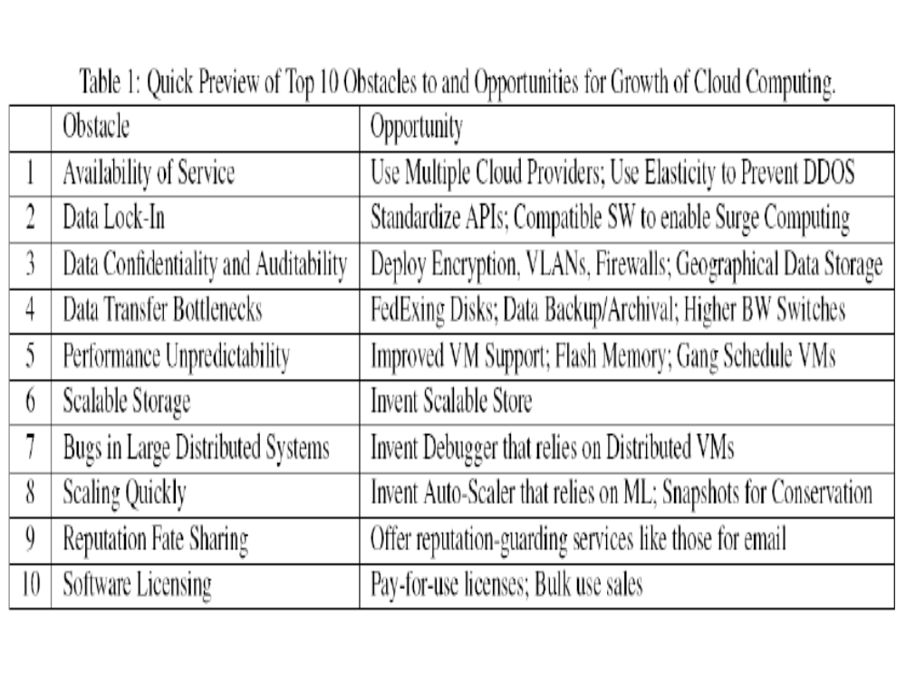
Table 6.2

Chapter 7

Applications and Future Prospects

- Provides a vast sea of application and storage at hand.
- Very useful for mobile and lighter clients.
- Help in creating a more efficient work environment by transferring the domain of storage and software administration to a single expert/admin.
- Relieve User from System mangement. Thus increase efficiency at work place

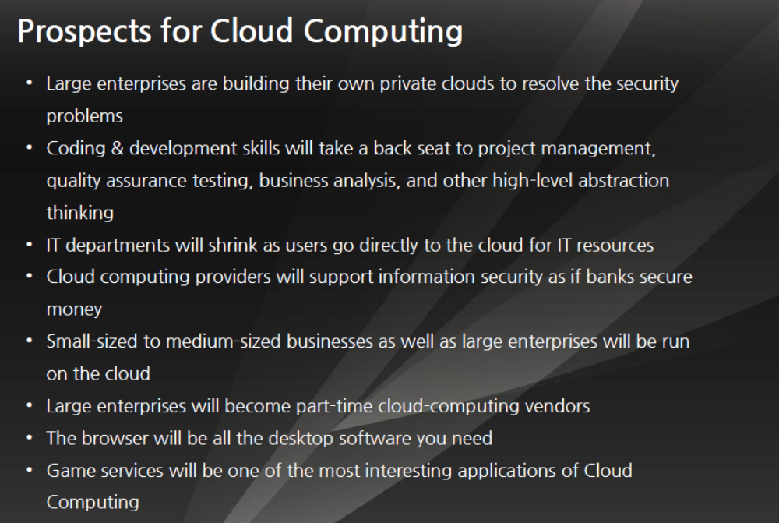
Table 7.1

Chapter 8

Software/Hardware Requirements

Considering the scale of our project, which is concerned with only a small scale implementation of the software and storage sharing, we can proceed with utilizing limited and easily available resources.

8.1 Software Requirements

Development Environment-

- Platform: Linux-Ubuntu-10.04 (Lucid Lynx)

- Language: C, C# ( graphical user interface)

- Compiler: gcc, Mono with GTK#

- IDE: geany, Visual Studio-2000

- Library: BSD Socket library, GTK#

Execution Environment-

- Operating System- Linux (all version)

- Package: GTK#, Mono

8.2 Hardware Requirements

- RAM: A minimum of 512 MB RAM

- HDD Memory Space: A minimum of 1.00 MB

- Network Interface

Chapter 9

References

We Considered the following books/websites/materials for gathering information regarding our work.

- http://www.google.com/

- http://www.wikipedia.com/

- http://www.w3schools.com/

- http://www.howstuffworks.com/

- “Cloud Computing: Introduction and Working” – A Report by Simon E. Bluster

- “Overlay Networks: A Briefing” – A Report by W.E Baron

- “SaaS: Future Scopes” – A Report by E.M. Smith

